Group Project
Project Plan

Contents

1. Introduction
1.1 Purpose of the Document
1.2 Scope
1.3 Objectives
2. Overview
2.1 Platforms
2.2 High Level Architecture
3. Use Cases
3.1 Use Case Diagram
3.2 Use Case Descriptions
4. User Interface Design
5. Gantt Chart
6. Risk Analysis

1 Introduction

1.1 Purpose of the Document
The purpose of this document is to show how we have interpreted the client’s specification, Reserve Plant Species Recording, into simple objective and milestones to be achieved.
The document is set out to define the interactions of the application and the overall appearance of the end user interface.
The document will also display a comprehensive Gantt chart displaying the project’s major tasks and milestones. As well as this there will be a risk analysis, which shall describe the main issues that could possibly be encountered throughout the development of the system and how these risks can be handled and or avoided.

1.2 Scope
The contents of this document should take into account the details of the group project specification.
The document includes the overview of the proposed system at hand, the choice of platforms to be used, a use case diagram entailing an overview of how the system will be expected to run, a description of the user interface design and end user interaction.
The document also includes a Gantt chart displaying start and end dates of tasks needed to complete the project. A risk analysis will also be available, displaying possible problems that may be encountered.

1.3 Objectives
The main objectives of this document are as to show all the different fields and aspects of the application

• To show a general sense of idea and the aspects of the application
• Record bugs and problems that has occurred and the solution
• Display how different component interact and behave with each other
• Provide criteria and standard the application must meet
• Record and provide milestones / achievements and progress

2. Overview

The proposed system is an Android based plant species recording application with an accompanying web interface, which both utilise a backend database stored on a server.

2.1 Platforms:
- Android: the client specified an app written for the Android mobile operating system
- Java: as subject to the client’s specification for an Android app, Java is the language natively supported by Android.
- PHP: as per the client’s requirements, we will be building a website that interacts with the database. PHP is a good choice for this due to it being developed with web development in mind, so it is easier to code than other choices. Also, a significant number of members of our team are learning PHP as part of a different module.
- MySQL: MySQL is a widely supported database platform, which is free to use and acknowledged by many in the industry as one of the best free options.
- JavaScript: We will use JavaScript to ease the load on the server, and perform some simple tasks client-side (eg when editing a record, checking the data the user has entered is in the right format).

2.2 High Level Architecture:
- Reserves: On the website, users will be able to enter and modify details about reserves (ie, areas of nature users have visited and recorded plant species data at).
- Plant Species: The main requirement of this project is for users to be able to make records pertaining to plant species and their abundance. This will be the main functionality/screen of the application.
- Photos: A user can optionally attach a photo of the particular plant species and/or the surrounding area, for this we will use Android’s built-in Camera and/or Gallery.
- Reserve Records: On the website, users will be able to view plant species records logged at a specific reserve, we will be using SQL calls to selectively choose this data and displaying it to the user in an attractive and readable format.
- Target User: As per the requirements specification, the target user for this application will be naturalists familiar with standard computer interfaces, and concerned particularly about accuracy of recordings. Using this knowledge, and common knowledge about mobile applications, we will strive to make our application simple and easy to use but with the flexibility to allow users to enter accurate data. People using this app will likely be outside, and of course be using their phone, so will not want to spend too long entering data into a confusing app.

3 Use Cases
3.1 Use Case Diagram
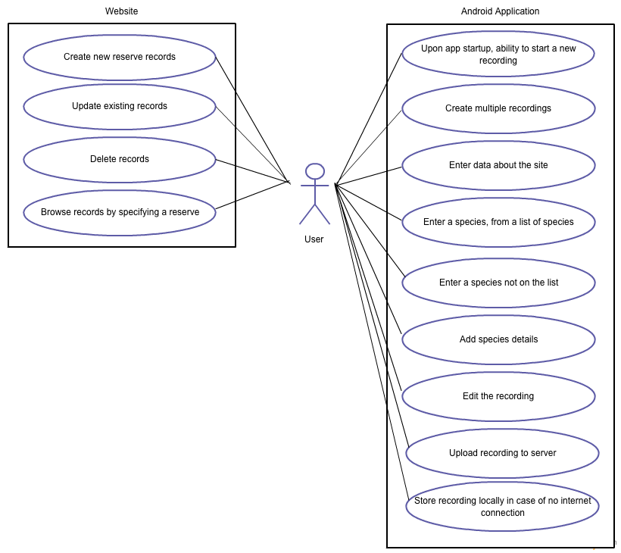

3.2 Use Case Descriptions

Android Application:

Use Case | Description | Requirement
Create a recording | Upon opening the app, the user will be able to create a new recording | FR1
Create multiple recordings | The user will be able to create multiple recordings (for multiple species, or areas) | FR1
Enter data about the site | User will enter data about the site they are at (eg, a nature reserve) | FR2
Enter a species | User will enter a species from a list of plant species provided by Botanical Society of Britain and Ireland (“BSBI List 2007”) | FR3
Enter a species not on the list | If the species the user has seen is not on this list, they will be able to provide a name for the species recorded | FR3
Add species details | User will add details about the species: abundance of species (using the DAFOR scale), location, and optionally a photo and a comment | FR4
Edit the recording | User will be able to edit their recordings, either by changing the details or deleting the recording. | FR5
Upload recording to server | User will be able to upload their recording to the server, which will in turn add it to the database. | FR6
Store recording locally | If an internet connection is not available, the user will have the option to store the recording locally (and upload it later when a connection is available). | (none)

Website:

Use Case | Description | Requirement
Create recordings | User will be able to create new reserve records through the website (with a name, location and description. | FR8
Update existing recordings | User will be able to update information stored in existing records. | FR8
Delete recordings | User will be able to delete records. | FR8
Browse records | User will be able to search for a reserve and browse species recordings taken at that location. | FR9

User interface design

Gantt chart

Risk analysis

